**Matriz LED de 8x8**

1. Objetivo

* Familiarizar al estudiante con el uso de componentes electrónicos

1. Materiales

* Arduino UNO
* Protoboard
* Matriz LED de 8X8
* Resistencias

1. Procedimiento

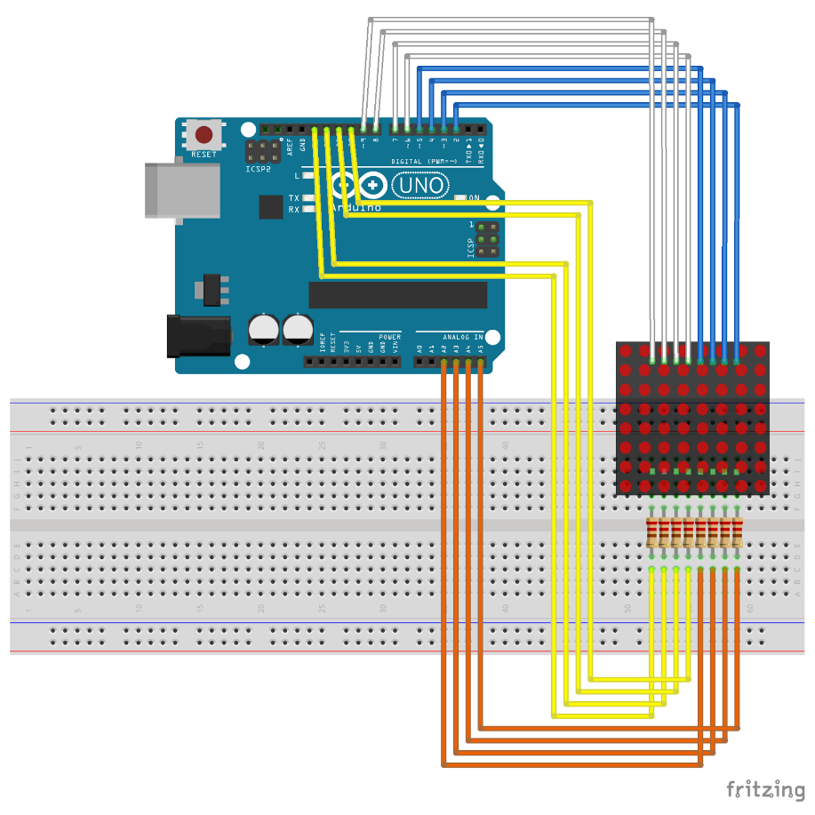

1. Código

const int row[8] = {2,7,19,5,13,18,12,16};  
const int col[8] = {6,11,10,3,17,4,8,9};  
int pixels[8][8];

int posX = 7;  
int posY = 7;  
int count = 30;  
bool bg = false;

void setup() {  
 for(int thisPin=0;thisPin<8;thisPin++){  
 pinMode(col[thisPin],OUTPUT);  
 pinMode(row[thisPin],OUTPUT);  
 digitalWrite(col[thisPin],HIGH);  
 }  
 setupScreen();  
}

void loop() {  
 refreshScreen();  
 if(count-- == 0){  
 count = 500;  
 if(posX--==0){  
 posX = 7;  
 if(posY--==0){  
 posY = 7;  
 bg = !bg;  
 }  
 }  
 setupScreen();  
 }  
}

void setupScreen(){  
 if(bg){  
 for(int x=0;x<8;x++){  
 for(int y=0;y<8;y++){  
 pixels[x][y] = LOW;  
 }  
 }  
 pixels[posX][posY] = HIGH;  
 }  
 else{  
 for(int x = 0;x<8;x++){  
 for(int y=0;y<8;y++){  
 pixels[x][y] = HIGH;  
 }  
 }  
 pixels[posX][posY] = LOW;  
 }  
}

void refreshScreen(){  
 for(int thisRow=0;thisRow<8;thisRow++){  
 digitalWrite(row[thisRow],HIGH);  
 for(int thisCol=0;thisCol<8;thisCol++){  
 int thisPixel = pixels[thisRow][thisCol];  
 digitalWrite(col[thisCol],thisPixel);  
 if(thisPixel==LOW){  
 digitalWrite(col[thisCol],HIGH);  
 }  
 }  
 digitalWrite(row[thisRow],LOW);  
 }  
}